Labo 3 Class D amplifiers

Bram Vanderwegen

# Introduction

Class D amplifiers, also known as digital amplifiers, represent a revolutionary advancement in audio amplification technology. Unlike traditional analog amplifiers that operate by continuously varying voltage to amplify signals, Class D amplifiers employ a pulse-width modulation (PWM) technique to efficiently reproduce audio signals. This design allows Class D amplifiers to deliver high-quality audio reproduction with significantly improved energy efficiency, making them an ideal choice for a wide range of applications, from home audio systems to professional sound reinforcement.

The fundamental principle of Class D amplification involves rapidly switching the output transistors between fully on and fully off states, thereby minimizing power dissipation and heat generation. This unique approach results in amplifiers that are not only compact and lightweight but also boast impressive power efficiency, making them particularly suitable for portable and energy-conscious applications.

# Design

## PWM signal

### Explain what a PWM signal looks like, and how it is generated in practice

Pulse-width modulation is a technique to convert an analog signal into a dc square wave signal. Here the Ton/T * Vin of the square wave determines the equivalent analog voltage. if the modulation frequency is high enough a constantly changing analog signal, such as a sine wave can be fully encoded this way. Visually this will look as a series of square waves with the duty cycle changing.

In practise it can be generated using an comparator where the inverting input has a triangle wave applied to it and on the non-inverting output the analog signal.   
Another way how a PWM signal can be generated is using a microcontroller. The microcontroller can output a digital signal for a specific time and consequently simulate the signal. Often these controllers have specific hardware dedicated to this. For example, the ESP32 microcontroller has the dedicated LEDC peripheral which can be used to create a constant and varying PWM signal: <https://docs.espressif.com/projects/esp-idf/en/latest/esp32/api-reference/peripherals/ledc.html>.

To illustrate the comparator example the following simulation was made

Figure 1: comparator circuit and PWM signal generated with both inputs and the output plotted

Here the triangle wave (blue), the input sine wave signal (green) and the output PWM signal (Red) are plotted. At the maximum value of the sine wave, the square wave has a high duty cycle as the signal is almost a pure 4V DC signal. The opposite happens near the bottom, where the signal is almost a pure 0V DC signal. You can see, when going from top to bottom that the duty cycle starts to decrease, and at the sine’s zero crossing the ton and toff are about even.

### What are the requirements on the frequency of the triangular waveform, with respect to the one of the input signal?

When modulating a signal the intention is to preserve the input data. This brings us to data theory and the sampling theorem. The Nyquist-Shannon theorem dictates the sampling frequency should be twice the signal frequency. For this circuit with the maximum signal frequency //, the sampling frequency is //. Here some tests have been done with the aforementioned example frequency of 1kHz. And an RLC filter.Afbeelding met schermopname

Figure 2: reconstructed signal (green) with sampling frequency 2x the signal frequency

Here we can see a sampling frequency of 2x preserves the signal, however the reconstructed wave is not perfect. This is probably due to the imperfections in the filter design, either calculation error or within the Q factor range, but not exactly being spot-on. This distortion continues for multiple increases of the carrier signal. At 10x the signal seems to be relatively stable, however the distortion is still visible, therefore we will be using the suggested 50x input signal for the remainder of the tests.

Figure 3: reconstructed signal (green) with sampling frequency 10x the signal frequency

Furthermore when choosing an comparator the slew rates need to be taken into account as they can cause the signals to be distorted seen here

Figure 4: the output (red) gets distorted when the comparator can't switch fast enough

## Amplification stage and filter design

### It is so that V1 and V2 are extremely close in terms of characteristic (form and voltage amplitude). In this case, why do you think it is necessary to use the power transistors to drive the output, i.e. why can we not only use the output of the comparator as input for the filter?

The comparator usually has a lower maximum current it can supply compared to discrete power transistors. While a high power comparator can be used, it is usually way more expensive than the cheap comparator + 2x power transistor combo.

### Why is it necessary to filter V2, and how does that work? Be specific!

Because V2 is still a square wave signal, it contains high frequency harmonics which were not in the original signal, when filtering the signal these harmonics get removed, leaving only the original input signal. This the removal of the high frequency components is done using a low-pass filter. If this doesn’t get removed in for example audio signals, there will be audible distortion. Sometimes a filter isn’t necessary if the output component already has a filtering effect.

### In the same fashion as for the first laboratory, design the filter such that it has an appropriate quality factor Q as well as a correct cut-off frequency. Explain why you choose these values.

The cutoff frequency of the LC filter can be calculated using the resonant frequency formula: $\frac{1}{2π\sqrt{LC}}$. The cutoff frequency should be calculated for the highest frequency as the lower ones will pass through the low-pass filter anyway.  
Then the quality factor needs to be calculated by first calculating the damping factor ζ and subsequently calculating the quality factor: $ζ=\frac{R}{2}\sqrt{\frac{C}{L}}$& $Q=\frac{1}{2ζ}$ here we chose Q = 0.75 as it is the average value desired for audio applications which are 0.5-1.5. This gives us the following values: c = 1.326µF & l = 109µH

### In order to show the correct functioning of your RLC filter, run a steady-state analysis (.ac) on it

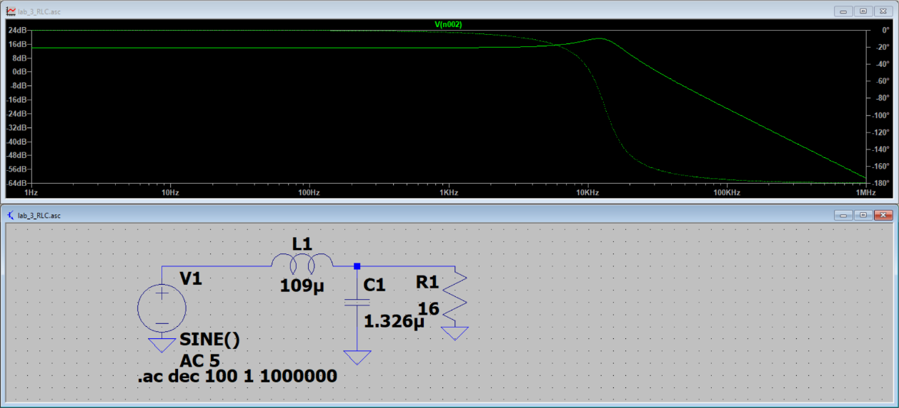

Figure 5: The RLC filter and its frequency response

This filter response clearly shows a low-pass filter. The lower frequencies do not get attenuated, but the higher frequencies do. Furthermore there is a resonant peak visible a bit beyond the cut-off frequency. This is probably due to rounding the values.

# Simulation

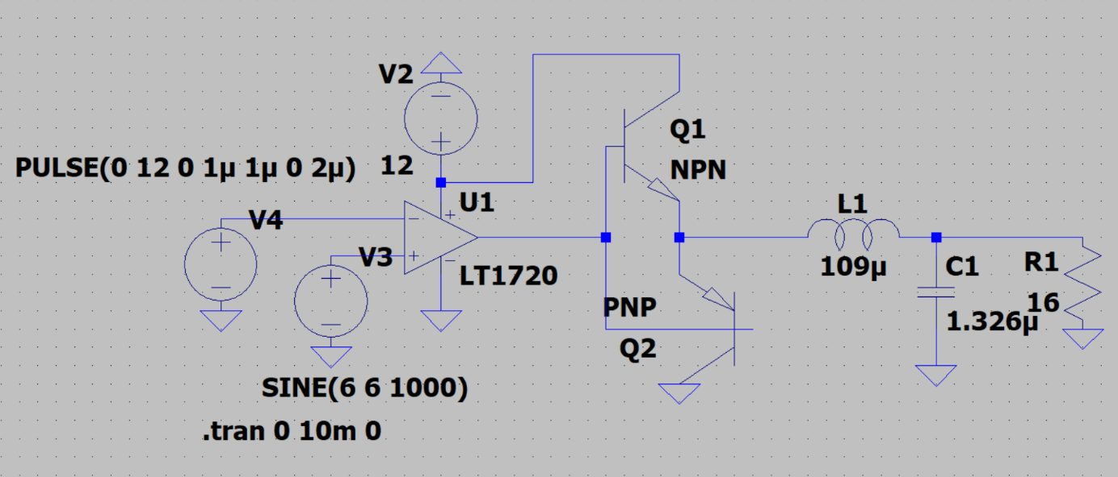

Figure 6: the class D amplifier circuit used in the simulations

## Show that it behaves normally throughout the whole range of frequencies (start, middle, end)

Figure 7: output (green) at 100Hz

Figure 8: output (green) at 1kHzAfbeelding met schermopname, lijn, Kleurrijkheid, Perceel

Automatisch gegenereerde beschrijving

Figure 9: output (green) at 10kHz

The output oscillates pretty much as expected, however some deviations are noticeable.

## Are there any non-idealities in the behaviour of your amplifier, or things you didn't expect?

There is some startup behaviour in the low frequencies, but this evens out after a while, and is of little importance. However the low frequencies do show the waveform capping out at around 10V and at 0V. The cause of this could be due to behaviour of the transistors. However this would be strange as it is not present at 10khz

Decreasing the Q factor does seem to solve this problem

Figure 10: same 1000Hz plot but with increased Q-factor of 10

Here the graph does not exhibit the behaviour but it does dampen the overall frequency. As the amplification through the resonant peak does not occur due to the overall frequency response being drawn out

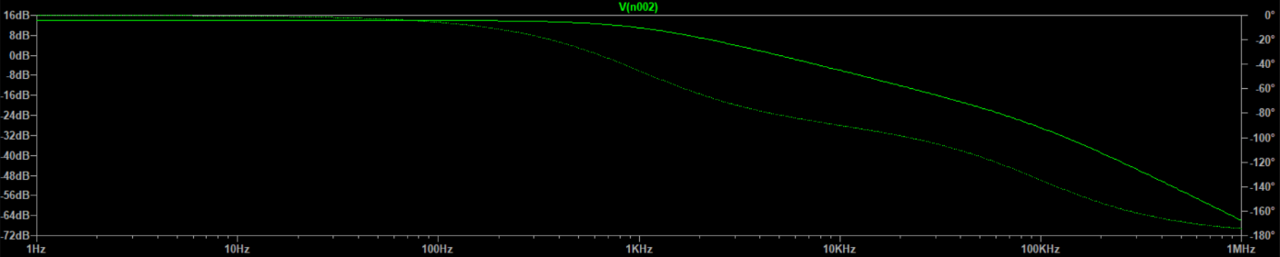

Figure 11: frequency response of the RLC circuit calculated with Q = 10

Here the filter has a higher amplification value for the lower frequencies and already starts to diminish before it reaches the 10kHz. Furthermore, the resonance peak is absent.

## Show how the amplifier behaves outside of the frequency range it was designed for. What happens when the frequency is:

### Too small.

The signal still gets filtered as with the other frequencies, and will show the original input signal. Although the value will be attenuated by a little bit because of the greater distance from the resonance peak.

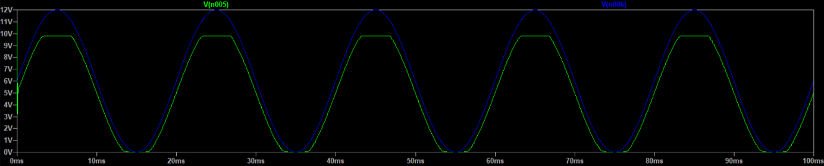

Figure 12: output (green) of a 50Hz input signal (blue)

### (b) Too big.

The signal get completely filtered out as both the modulation and modulated signal is beyond the filter cutoff frequency. This will come out the filter as a really small sine wave.

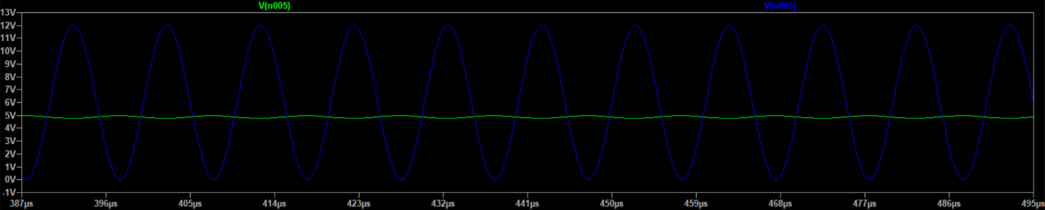

Figure 13: output (green) of a 100kHz input signal (blue)

# Conclusion

The class D amplifier is a useful amplifier as mentioned above. While the generation of the PWM signal and the amplification is rather easy, the power and bandwidth/slew rate properties of the comparator and power transistors need to be taken into account. Furthermore taking the sampling frequency multiple times higher than the minimum rate, defined by the Nyquist-Shannon theorem, visibly (and audibly) increases the quality of the signal.

Making the filter can be quite tricky but with the right formulas it can be a breeze. The filter can attenuate signals within the pass band a little bit, which should be taken into account.

The simulations do show the output is not completely as expected and also lets the Q factor shine. As it influences the bandwidth over which the amplifier works effectively. Furthermore, this is an interesting phenomenon as I found sources which states the Q factor for audio applications should be within 0.5-1.5 this is well within the given range of 100-10kHz. Therefore it is rather strange the lower frequencies were impacted by the Q factor. This actually leads me to believe there is another effect at play, most likely in the comparator or in the transistor bridge.